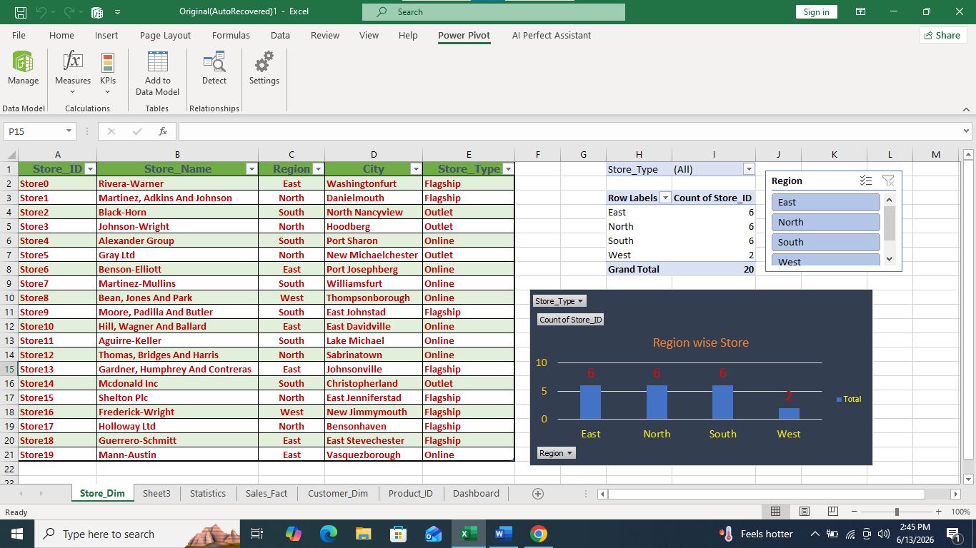
- Region-wise store analysis shows that store distribution is uneven across different regions. Some regions have higher store presence, indicating stronger market coverage, while others have fewer stores, suggesting expansion opportunities. This helps identify key regions for business growth.

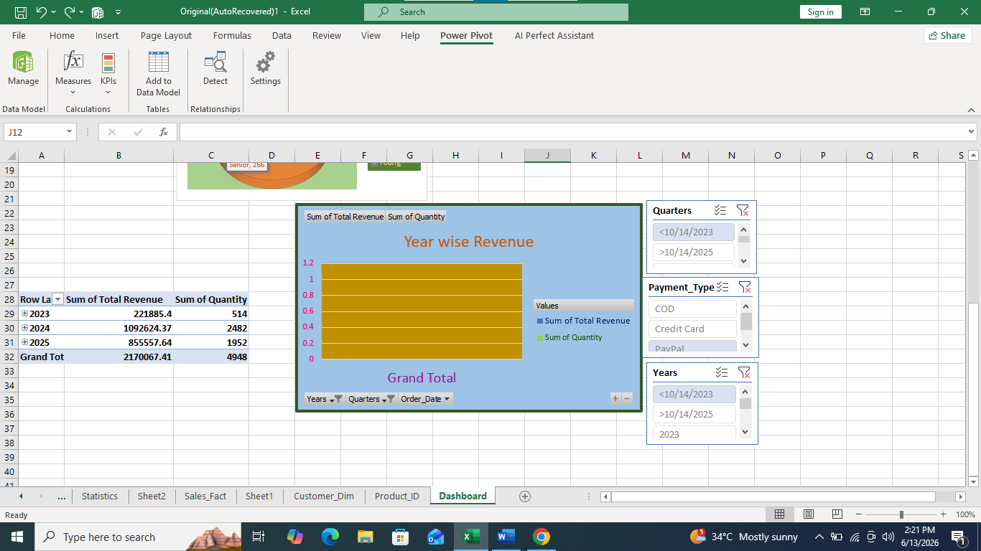

- Year-wise analysis of revenue and quantity shows a clear trend in sales performance over time. It indicates how total revenue and quantity sold have changed across different years, helping to identify growth or decline patterns. This insight supports understanding of overall business performance over time.

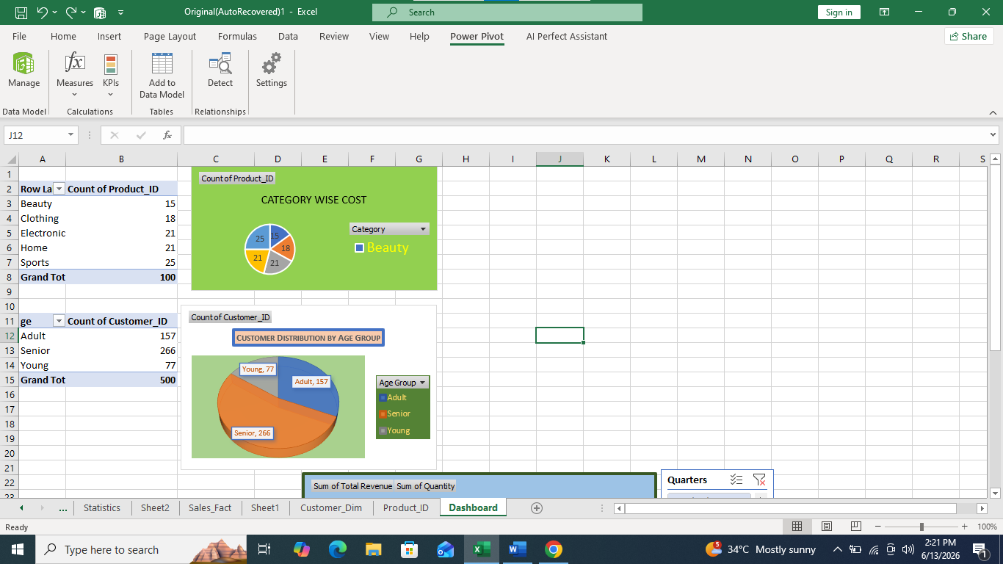

- The analysis of product sub-category wise cost shows the cost distribution across different product groups, helping to identify high-cost and low-cost categories. Additionally, the age category analysis shows the distribution of customers across Young, Adult, and Senior groups, highlighting that certain age segments contribute more to the customer base. These insights help understand both product cost structure and customer segmentation patterns.
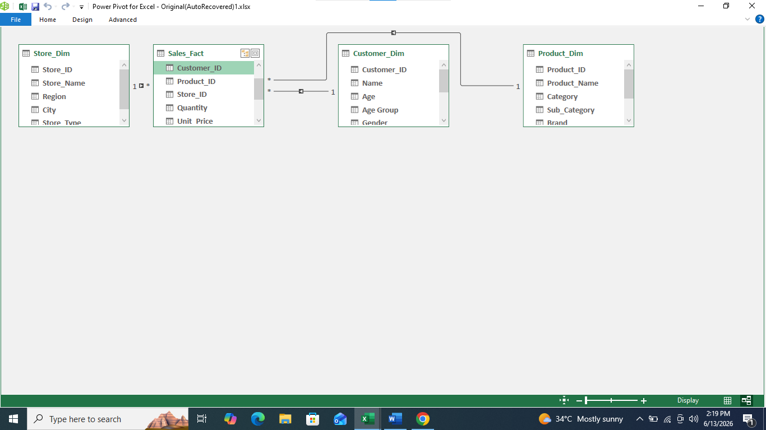

- The Pivot Table is connected using relationships between the Customer, Sales, Product, and Store tables. Customer ID, Product ID, and Store ID are linked with the Sales table to enable integrated analysis across all datasets. This relationship setup allows dynamic filtering and accurate aggregation of data across different dimensions.
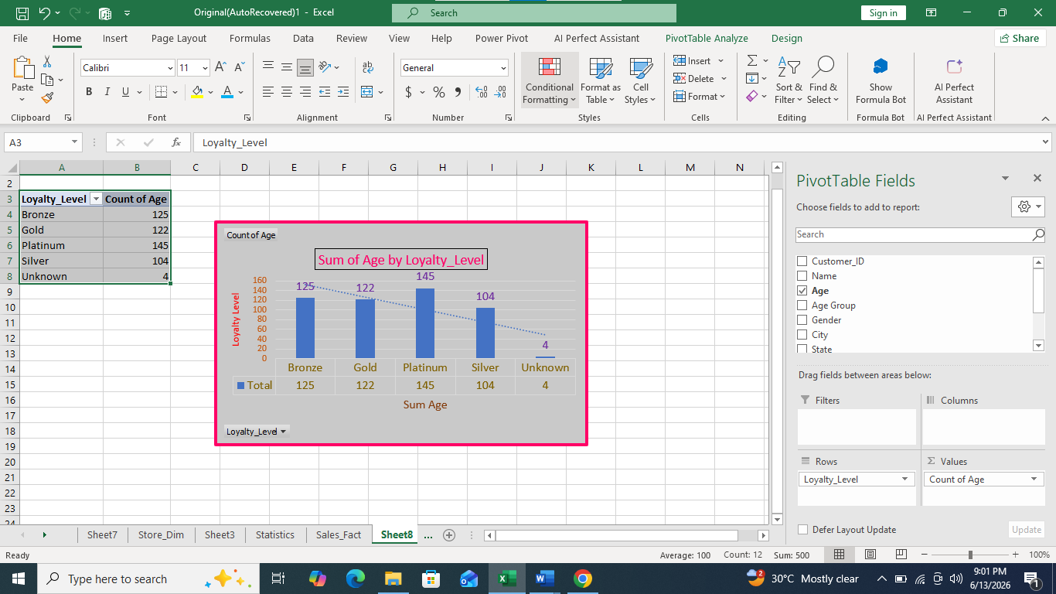

- The analysis of Loyalty Level with Age count shows the distribution of customers across different loyalty segments such as Gold, Silver, and Platinum. A combined bar and line chart is used to visualize the variation in customer count across these categories. This helps in clearly identifying which loyalty levels have higher or lower customer concentration.
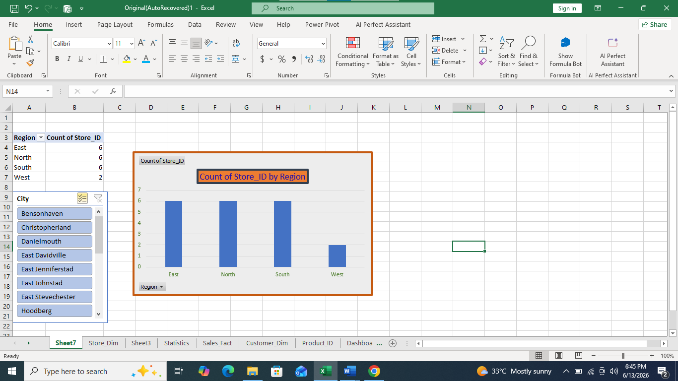

- The analysis of customer count by region shows how customers are distributed across different regions. The bar chart highlights variations in customer concentration, indicating which regions have higher or lower customer presence. This helps identify key regions with strong customer base and areas with potential for customer growth.
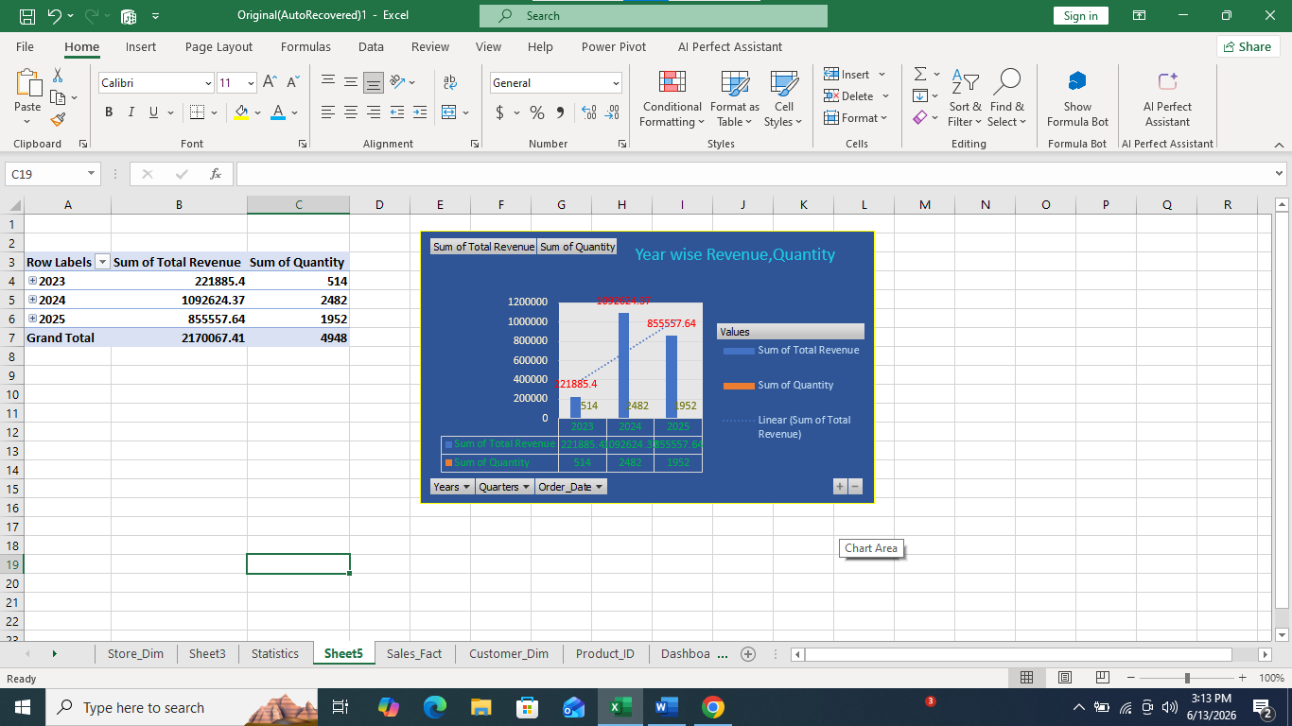
- The chart shows the distribution of customers across different loyalty levels such as Gold, Silver, and Platinum. It indicates the number of customers present in each category based on age count.

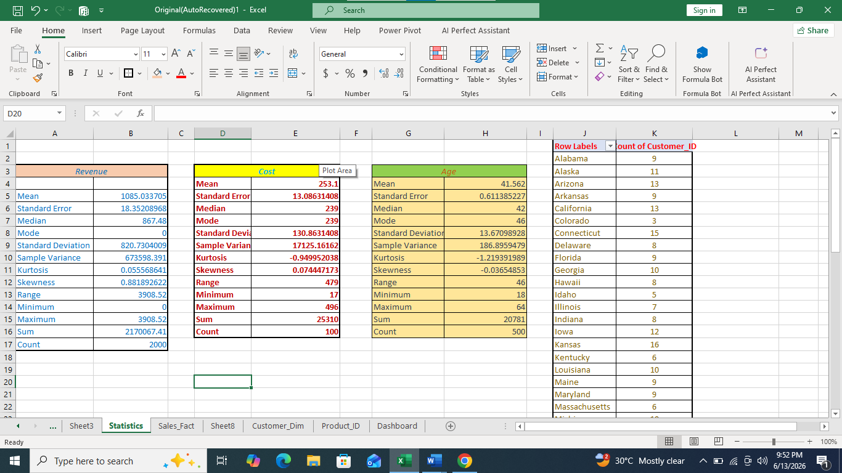

Revenue Statistics Analysis:-
The Revenue dataset shows that the Mean Revenue is higher than the Median Revenue, indicating the presence of a few customers generating significantly higher revenue than the majority. The positive skewness value suggests that the distribution is right-skewed, meaning most customers contribute moderate revenue while a small number contribute exceptionally high revenue.

Cost Statistics Analysis:
The Cost dataset has Mean, Median, and Mode values that are relatively close to each other, indicating a balanced distribution. The skewness value is close to zero, suggesting that the data is approximately symmetric. This reflects a stable and consistent cost pattern across the observations.

Age Statistics Analysis:
The Average (Mean) Age of customers is approximately 42 years. Since the Mean and Median values are very close, the age distribution is fairly balanced. The standard deviation indicates a moderate variation in customer ages, showing that the customer base includes individuals from different age groups.

State-wise Customer Distribution Analysis:
The state-wise customer analysis shows that customers are distributed across multiple states. Some states have a higher concentration of customers, while others have relatively fewer customers. This information can help identify regions with strong customer presence and highlight areas where additional marketing efforts could improve customer acquisition and business growth.

